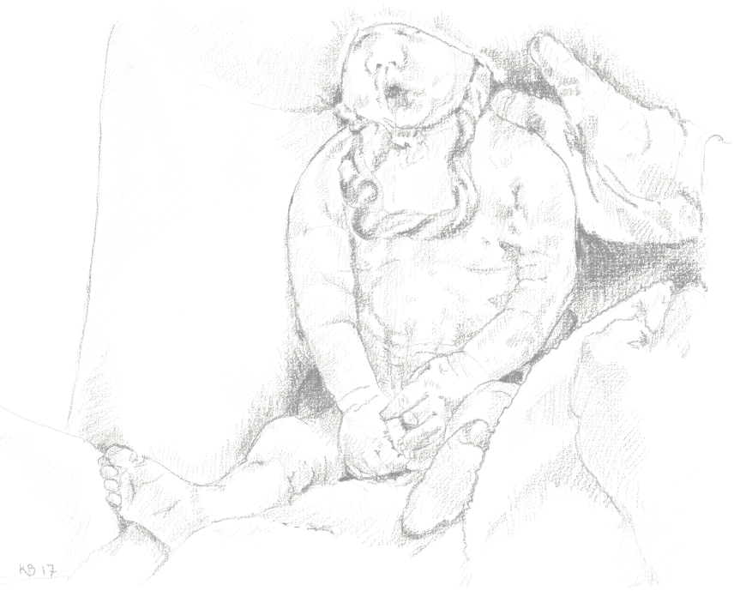
Upright breech seminar
March 17th 2023
Aabenraa, Denmark
Teachers:
Obstetrician Dr. Andrew Bisits (AUS), Obstetrician Kamilla G Nielsen (DK)
Midwife coordinators Louise Horskjær and Karin Raundahl (DK)
Program
8.30 – 9.00 Arrival and breakfast
9.00–9.30 Welcome. Upright breech in Denmark. Kamilla G Nielsen
9.30–10.15 The uncomplicated breech birth. Videos. Kamilla G Nielsen
10.15-10.30 Pause
10.30-11.10 The complicated breech birth. Videos and manouvers. Kamilla G Nielsen
11.15-12.15 Breech workshops 1-3
12.15-13.15 Lunch (Delivery suite tour or Breech movie theater)
13.15-14.10 Breech workshops 1-3
14.10-15.05 Breech workshops 1-3
15.05-15.25 Pause
15.25-15.55 Breech, CTG and feet. Kamilla G Nielsen.
15.55-16.25 The breech conversation. Andrew Bisits and Louise Horskjær
16.25-16.45 Quizz. Questions and comments
Workshop 1  Complicated breech births  Louise Horskjær  Kamilla G Nielsen  Room | Workshop 2  Meet the expert  Andrew Bisits  Iglo | Workshop 3  Hands on training  Karin Raundahl  Room

